Minutes of Berryfields Parish Council Meeting
held at Roman park, Sir Henry Lee Crescent, Aylesbury, HP19 0YT
on Wednesday 17th November 2021
Present: Councillors Louise Rees, Laurilee Green (Chairman), Bindu Gundapudi, Paul Redshaw, Arun Sekhar, Naser Habib (Vice Chairman), John Yandrapati, Gareth Lane, Sue Severn (Parish Clerk), Anthea Cass (Deputy Clerk) and Agnes Alborzpour (Assistant Clerk), Councillor Ashley Waite (Buckinghamshire Council), Councillor Paul Irwin (Buckinghamshire Council)
1. | Apologies for absence  No apologies received
2. | Declarations of Interest in items on the agenda  None
3. | Open forum for parishioners  No members of public attended the meeting.  Cllr Waite explained his role as Community Board Chairman and gave a quick overview of the recent meeting in November as well as the opportunity for potentially available grants.  Cllr Irwin said about the Christmas actions that both councillors are involved with; Inspire Bucks charity helping children in need with a county-wide toy appeal, and The Bernwode Bus Charity is looking to deliver 200 hampers for disadvantaged families across the area.  They also touched on the current update with East-West Rail and Berryfields Parkway and the reported parking issues on some roads around the Berryfields estate.
4. | Police report and Neighbourhood Policing  No written report received.  The Clerk reported that recently there had been a rise in vandalism on Berryfields Green, the basket board was damaged. Police was informed and promised to monitor the area more closely.
5. | Planning  21/04394/APP | Householder application for loft conversion with front and rear Velux windows | 7 Merton Close Aylesbury Buckinghamshire HP18 0ZN  Full Details: https://publicaccess.aylesburyvaledc.gov.uk/online-applications/applicationDetails.do?activeTab=summary&keyVal=R2GWW3CLIY900&prevPage=inTray  The Parish Council is neutral in respect of this application and had no comment to make.  Proposed by: Cllr Naser Habib  Seconded by: Cllr Paul Redshaw  Agreed unanimously
6. | Minutes  The draft minutes of the Parish Council Meeting held on 20th October 2021 were approved and signed as a true record by the Chairman.  Proposed by: Cllr Louise Rees  Seconded by: Cllr Vernon Hill  Agreed unanimously
7. | Land & facilities  Roman Park & Village Hall  Build progress is as reported.  Allotments  Nothing to report  Park inspections  There has been further vandalism at Berryfields Green. The basketball backboards which were replaced last month have, again, been vandalised. One has broken in two having been kicked so hard it broke. Given that these are very robust it must have been done with much force. A parishioner reported to us that he saw youths climbing up the netting of the MUGA and climbing over the hoops. Councillors now need to decide whether to replace the rings/backboards or have them removed for safety.  Memorial Policy  Memorial Policy has been approved.  Proposed by: Cllr Arun Sekhar  Seconded by: Cllr John Yandrapati  Agreed unanimously
8. | Finance  8.1 The payment run agreed as circulated and budgeted payments made outside the Parish Council meeting were ratified.  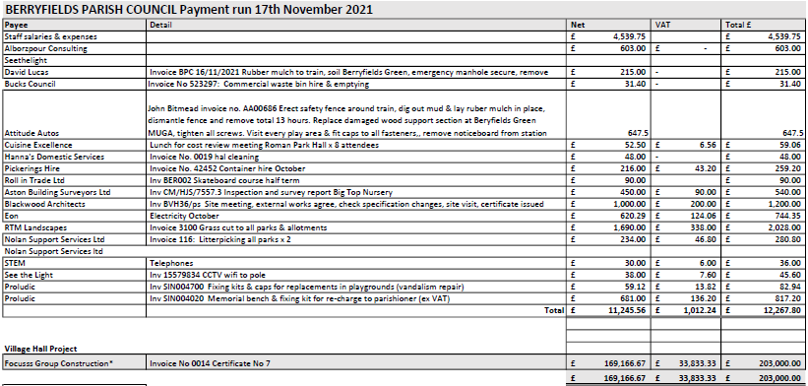  8.2 The accounts to the end of October 2021, were agreed as circulated.  Proposed by: Cllr Paul Redshaw  Seconded by: Cllr Louise Rees  Agreed unanimously
9. | Events  Berryfields Buddies  Coffee mornings are now held on Wednesday mornings and some regular attendees who report that they enjoy them. The walk along Greenway was much enjoyed and Anthea has booked Boxing Day table at Miller & Carter for those who are alone and would like to go.  One of the Buddies has kindly offered his services as Father Christmas in Watermead due to Ashley’s absence on the night – Nigel is absolutely delighted and thrilled to have been asked, which is lovely. This is a positive outcome of Buddies involvement. He’s also joining in with other social events.  HM Queen’s Platinum Jubilee Event  Councillor Sekhar is leading the organisation of this event. The proposal is to organise a community picnic, children entertainment, an evening entertainment, beacon lighting, food stalls etc.  The clerk will look at licensing of the event and put all safety procedure in place.  Event working group will be established closer to the event.  Advertising of the event was discussed.
10. | Berryfields News & Communication  December edition being completed. New approval process now in place for advertising and confirmation required from each advertiser that they own any copyright/design and approve the advert before publication.
11. | Highways & transport  Cllr Hills wrote an article about safety to be published in the Berryfields news.
12. | Meetings and matters to report  Cllr Hills completed training for parish councillors.
14. | Date of next Parish Council meeting  Wednesday 19th January 2021

