Minutes of the Annual Parish Council meeting
at Roman Park Hall, Roman Park, HP18 0YT
on Wednesday 19th May 2021 at 7.30pm

PLEASE NOTE: The meeting was commenced immediately after the Annual Report of the Council
had been delivered to the meeting.

Cllr Inch delivered the report to the Council as the Parish Annual meeting couldn’t take place.

1 | Election of the Chairman of the Council and the Chairman’s Declaration of Acceptance of Office  Cllr Inch opened the meeting and asked for nominations for the position of Chairman. Cllr Green was proposed by Cllr Lane and seconded by Cllr Rees.  Councillors present voted in favour of Cllr Green being elected as Chairman.  Cllr Green accepted the position of Chairman and signed the Declaration of Acceptance of Office.
2 | Election of the Vice Chairman of the Council and the Vice Chairman’s Declaration of Acceptance of Office  Cllr Green asked for nominations for the position of Vice Chairman. Cllr Rees was proposed by Cllr Green and seconded by Cllr Harmes.  Cllr Habib was proposed by Cllr Lane and seconded by Cllr Hills.  Councillors present voted in favour of Cllr Habib.  By majority Cllr Habib was elected. Cllr Habib accepted the position of Vice Chairman and signed the Declaration of Acceptance of Office.
3 | Apologies for absence  No apologies
4  5 | - Declarations of interests  - No declaration of interest  - General Power of Competence  Councillors agreed that Berryfields Parish Council will adopt the General Power of Competence having met the criteria. All councillors are elected and the Parish Clerk and Deputy Parish Clerk are suitably qualified.  Agreed unanimously
6 | - Open forum (under adjournment): two members of public joined the meeting by zoom, no questions were asked.
7 | - Police report and Neighbourhood Policing  - No report from neighbourhood policing team was received.
8 | Planning  21/01548/APP | Erection of 2 commercial units with a mixed (flexible) B1 and B2 | Land Off Sir Henry Lee Crescent Aylesbury Buckinghamshire  Full details: https://publicaccess.aylesburyvaledc.gov.uk/online-applications/applicationDetails.do?activeTab=summary&keyVal=QRGI1QCLI5400&prevPage=inTray  Berryfields Parish Council is neutral in respect of this application.  Proposed by: Cllr Naser Habib  Seconded by: Cllr Paul Redshaw  Agreed unanimously  21/01631/APP | Single storey rear extension | 3 Pippin Road Aylesbury Buckinghamshire HP18 0FW  Full details: https://publicaccess.aylesburyvaledc.gov.uk/online-applications/applicationDetails.do?activeTab=summary&keyVal=QRPAIYCLIC200&prevPage=inTray  Berryfields Parish Council is neutral in respect of this application.  Proposed by: Cllr Gareth Lane  Seconded by: Cllr Louise Rees  Agreed unanimously
9 | Minutes of the Parish Council meeting held on 21st April 2021  The draft minutes circulated were approved and signed as a true record by the Chairman.  Agreed unanimously
10 | - Land & facilities  - Roman Park & Village Hall:  Resolution: to discharge the Planning Condition, the Councillors agreed to hire 30 parking spaces from Chiltern Railway, which will enable the Council to discharge the condition without building car park 2 at this moment because Council does not have funds.  Proposed by: Cllr Gareth Lane  Seconded by: Cllr Louise Rees  - Agreed unanimously  - Construction of the Village Hall started on 5th May. The archaeology briefing watch was completed and no issues were raised, meaning the construction work is allowed to carry on.  - Temporary hall  Possible opening of the hall for limited lettings from June 2021. We have to wait for Government guidance but we are hopeful that small groups will be possible.  - Allotments  Deputy clerk updated on lease, only two plot holders handed their plots back and they have been rented to next people on the waiting list. The waiting list is currently closed with over 30 on it. Wells are working at this moment at approximately 70% capacity and we are still trying with Aqua to fix the problem.  Park inspections/repairs  All parks are in good shape with a few minor repairs and maintenance required. Recently, at Marston Green, we have to change the rotary swing wires as they are tearing off. This equipment is currently closed.

Finance
11.1 The payment run was agreed as circulated and budgeted payments made outside the Parish Council meeting were ratified.

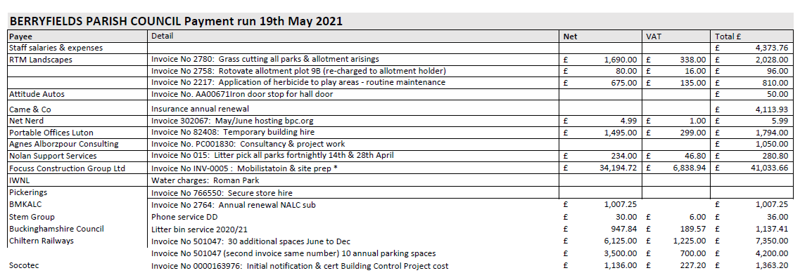
- 11.2 Insurance Renewal was accepted.
- 11.3 The list of standing orders and direct debits still to come.
11.4 Councillors agreed additional signatories for Lloyds Bank accounts. (Deputy Clerk and Chairman).
Proposed by: Cllr Naser Habib
Seconded by: Cllr Louise Rees
Agreed unanimously

- 2021 Events
Berryfields Buddies outdoor launch is on 4th June 2021.
- This is a loneliness initiative for residents; we are trying to reach to residents that do not have family or friends and would like social company. The idea behind this first session is to formulate a group and they can start to decide what they would like to do.
- Coronavirus Act & Covid-19 situation report
- Nothing new to report, we are following all official government guidelines and legislation.
- Berryfields News & Communication
The latest Berryfields News publication has been sent to the printers and will be distributed from the beginning of next week. The full cost of printing and distributing is covered by the advert’s revenue.
Cllr Green updated on the final version of the Welcome Letter that will be sent for comments.
- A working group meeting in relation to website will be arranged.

- Highways & transport
MVAS & Sentinel:
- Cllr Inch updated on the situation.
- The Sentinel camera is placed on different roads so that wherever there is a problem, the MVAS can collect data. We have a problem with the MVAS battery replacement as there is a shortage from all suppliers. The National Speed Watch program restarted in the past few weeks after lockdown easing.
- Cllr Hills and Cllr Habib volunteered to help with coordination of the scheme in Berryfields.

- Meetings & matters of report
- No meeting to report.
- Cllr Habib introduced Neighbourhood watch and asked councillors to join and promote it.
The Chairman thanked Cllr Inch for the work he has done over the past twelve months.

- Date of next Parish Council Meeting
Wednesday 16th June 2021

